# Lab 1.2: Creating a Virtual Machine

## Objectives:

* What is a virtual machine, and what is their purpose?
* Downloading and Exploring Virtualbox
* Computer Hardware Refresher
* Creating our first virtual machine in Virtualbox

A message from XYZ Corporation:

As our company continues to grow, we’re working hard to establish a solid security framework. We’re considering moving to Ubuntu Linux to minimize our attack surface, but don’t have the spare hardware to delegate for installing it.

We’d like it if you could make a Ubuntu Linux virtual machine so we could give the staff an opportunity to try the operating system, as well as to allow us to further investigate if moving all of our architecture over is a good time investment.

### Topic 1: What is a virtual machine, and what is their purpose?

Imagine you’re going on an extended vacation to a foreign country with your family. You might have some shared suitcases for items like toiletries, but you would like to have your own suitcase to keep your belongings organized and separate from others.

Virtual machines serve this same purpose on your computer. You may want to have multiple operating systems or applications that run on your machine, but keep them separate from each other, or outsiders. According to VMWare, a provider of virtual machine software, a virtual machine or VM is “a compute resource that uses software instead of a physical computer to run programs and deploy apps” (1). In other words, virtual machines are digital containers that can host operating systems or applications in a separate environment on your computer.

### Topic 2: Downloading and Exploring Virtualbox

Now that you know what a virtual machine is, it’s time to get some software so we can begin exploring them. For this lab series we’ll be using a software called **Virtualbox**. You can download it for your respective operating system [*here*](https://www.virtualbox.org/wiki/Downloads).

After you begin the download, you should see the file in your Downloads folder. We have downloaded the windows .exe file since we are running Windows, but downloads on Mac should come with a .dmg file. Double click on the file to run it, and you should see the wizard. You may get a user account control popup, just click ‘**Allow**’ to continue the installation.

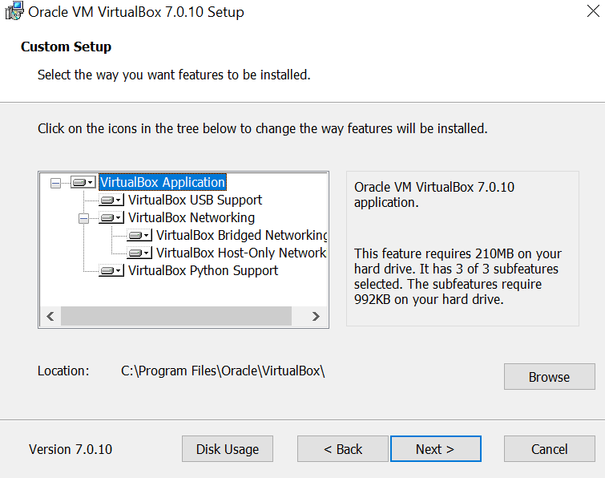

Continue walking through the Installation Wizard, clicking ‘**Next**’, ‘**Next**’, and ‘**Install**’. Make sure to *install the network features immediately* when it prompts you, as these will be used later in the course to provide you with a virtual network to perform all your testing on in a safe environment.

Once the installation is complete, you can close the Wizard and proceed to open the Virtualbox software.

#### A Note on Alternative Virtual Machine Softwares

There are alternative virtual machine softwares such as Google’s Cloud Platform, VMWare, and KVM Hypervisor. For these tutorials we’ll be looking mainly at Virtualbox because it is a free platform that is accessible to everyone. Each platform has various pros, cons, and use cases, so it’s worth looking into the others if you are curious. We’ve provided some links below under ‘Resources’ for these.

#### Virtualbox C++ Redistributable Error

You may receive the following error if you are on the windows platform.

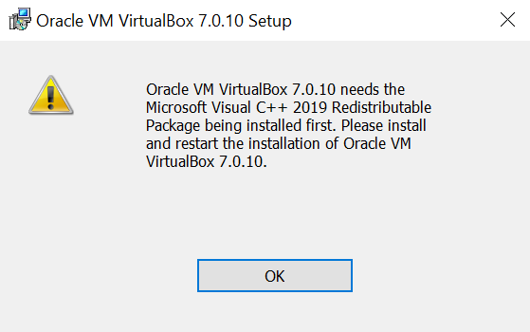

As you can see, this error occurs because we do not have Microsoft’s Visual C++ Redistributable downloaded. Make a note of the year that they have requested (in this case, 2019) and close both the window and the Virtualbox installation Wizard.

Navigate to the Microsoft C++ Redistributable downloads page [here](https://learn.microsoft.com/en-us/cpp/windows/latest-supported-vc-redist?view=msvc-170), and download the version that contains the same year that is stated in your error. In this case, the error stated that the wizard needed the 2019 Redistributable, so you should download the 2019 version. Once this is installed, try to open the Virtualbox Wizard again and it should work normally.

#### 

#### Getting Familiar with Virtualbox UI

Once Virtualbox is open, you should see the Virtualbox UI. Let’s take a moment to get familiar with it.

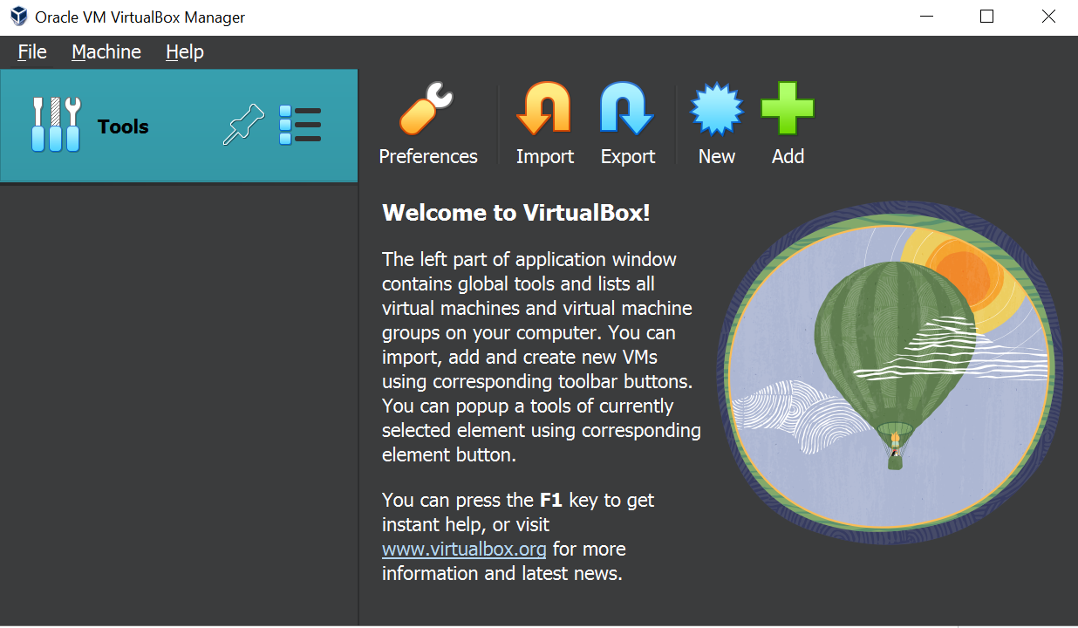

First, try to answer the following questions:

* *What button would you click to change the screen size of the virtual machine?*
* *What button would you click if you wanted to create a new virtual machine?*
* *What is the difference between the ‘Import’ and ‘Add’ buttons?*

Once you’ve answered these questions, move on to the next page to see what each button does in further detail.

The ‘**Preferences**’ button will open an interface that allows you to change the display settings, input devices, and update the software among other features.

The ‘**Import**’ button will allow you to import virtual machines that others have created using Virtualbox that are stored in a .OVF format.

The ‘**Export**’ button will allow you to export your virtual machines to a file format that others can use to Import it to their Virtualbox installation using the .OVF format.

The ‘**New**’ button will allow you to create a new virtual machine. We’ll look at this further in just a moment.

The ‘**Add**’ Button is very similar to the ‘Import’ button, but will allow you to add virtual machines from a .vbox file.

Feel free to continue tinkering with the different settings and buttons to get a feel for where different options are in the interface. Also, make sure to check back later, as there will be more settings available to you after we create our first virtual machine.

### Topic 3: Creating our first Virtual Machine (VM)

Now that we have Virtualbox installed, and we’ve taken some time to explore the interface, we can get started with creating our first virtual machine. First, we’ll have to grab an ISO file, which stands for ‘Image Standard Optical’. An ISO file contains the disk image data used to create the basic files needed for the operating system to perform its installation.

For our first virtual machine, we’ll be using **Ubuntu Linux**. This Linux distribution is very common, easy to install, and has an intuitive user interface.

Download the .iso file for the latest stable version (LTS) of Ubuntu Linux [here](https://ubuntu.com/download/desktop).

#### Naming and Selecting the Virtual Machine & Operating System

After downloading the .iso file, in Virtualbox click **‘New**’. Give your virtual machine a name you will remember that *does not contain spaces,* like Ubuntu-LTS, and select the ISO image by clicking the **drop down arrow**, clicking ‘**other**’, and finding the **.iso** file.

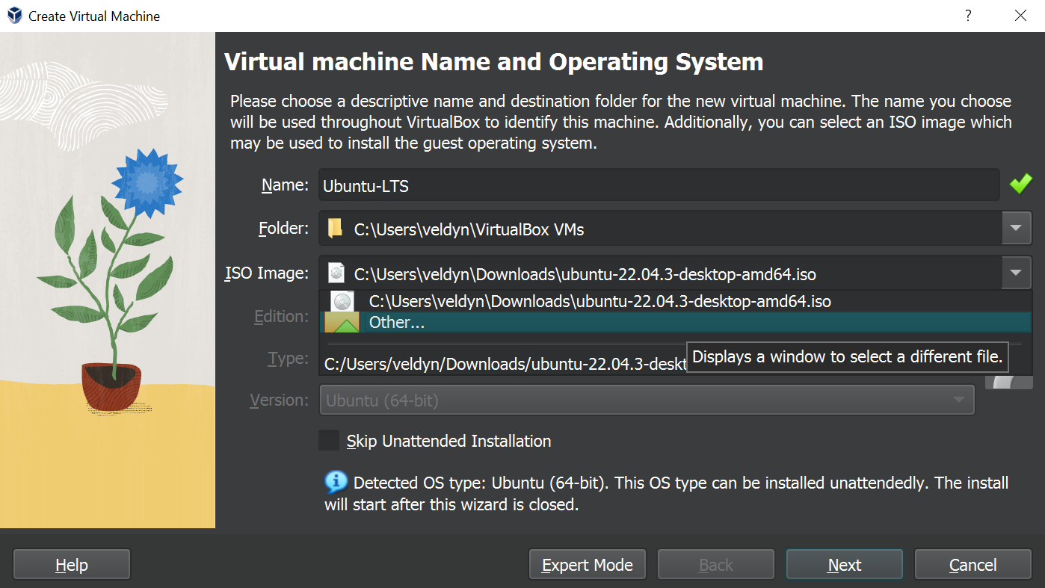

After selecting the .iso file, the edition and type fields should auto-fill, so go ahead and click ‘**Next**’.

#### Creating a Username and Password

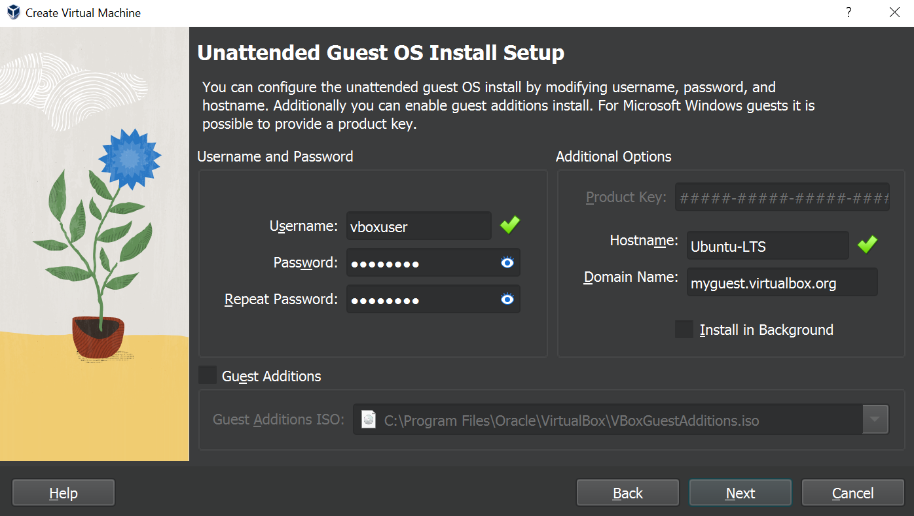

Now you’ll need to give your account a **username** and **password**. Make sure you pick ones that you will remember. Also, if you used an illegal character when creating your Hostname on the previous page, you will be prompted to adjust it here.

*\* Don’t worry about the product key, as this is only for Windows virtual machines.*

#### 

#### 

#### Computer Hardware Refresher

Before we start assigning hardware, it’s important to cover what the different components of a computer are, as well as their function. This will help develop a better understanding of the role of each component we will be assigning, and why they are important for our virtual machines to run smoothly. Complete the mini-quiz below to check your understanding of each component before continuing.

| Computer Component | What does it do? |
| --- | --- |
| CPU (Central Processing Unit) / Processor |  |
| Random Access Memory (RAM) |  |
| Graphics Processing Unit (GPU) |  |
| Hard Drive (HDD) / Solid State Drive (SSD) |  |
| Motherboard (MOBO) |  |

If you find yourself having trouble or want to check your answers, view the ‘Resources’ section of the Lab to find an overview and the answer key.

#### 

#### Assigning Hardware to the Virtual Machine

Now that we have recapped what different hardware components are responsible for, we can begin assigning hardware to our virtual machine.

First, we need to select how many **Processors** and how much **RAM** will be assigned to this virtual machine. You should assign at least 1 CPU with 2048MB of base memory, but feel free to assign more if your system has plenty of resources.

You can always modify these values later if you find that you need more, or are using too many resources.

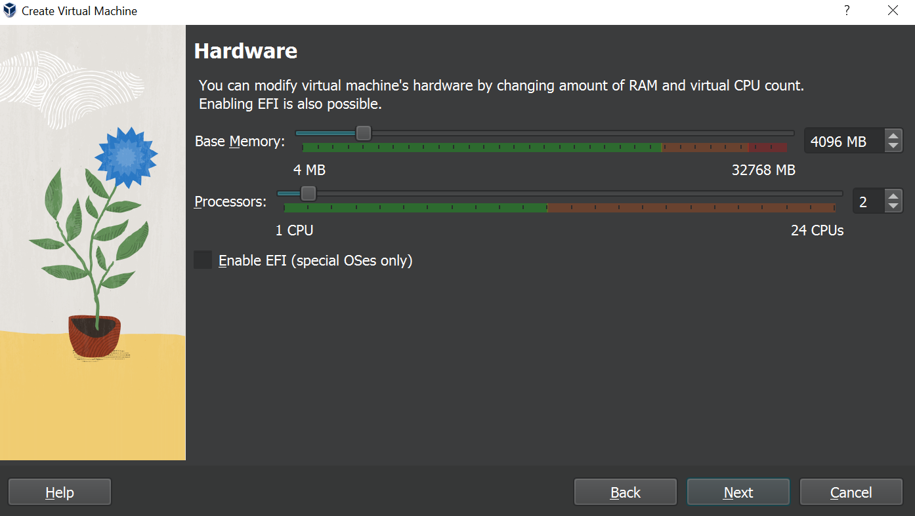

Now that we have assigned the processors and ram, we need to create a virtual hard disk. The virtual hard disk will be the only region of memory that the virtual machine can access on your host system, and it can be difficult to modify later, so it’s important that we allocate enough space. For our uses, 30GB is plenty of storage space.

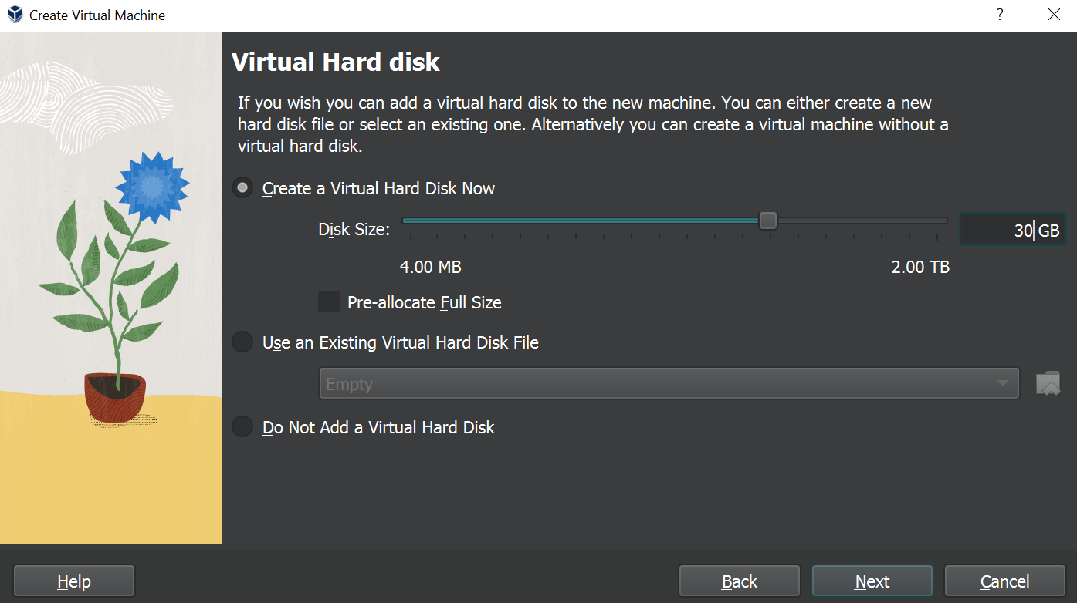

Keep in mind that this storage space has to be large enough to include the operating system, with 3GB extra at minimum to perform basic tasks on the machine. With this in mind, if Ubuntu requires 1.5GB of storage space, how much storage space should you allocate?

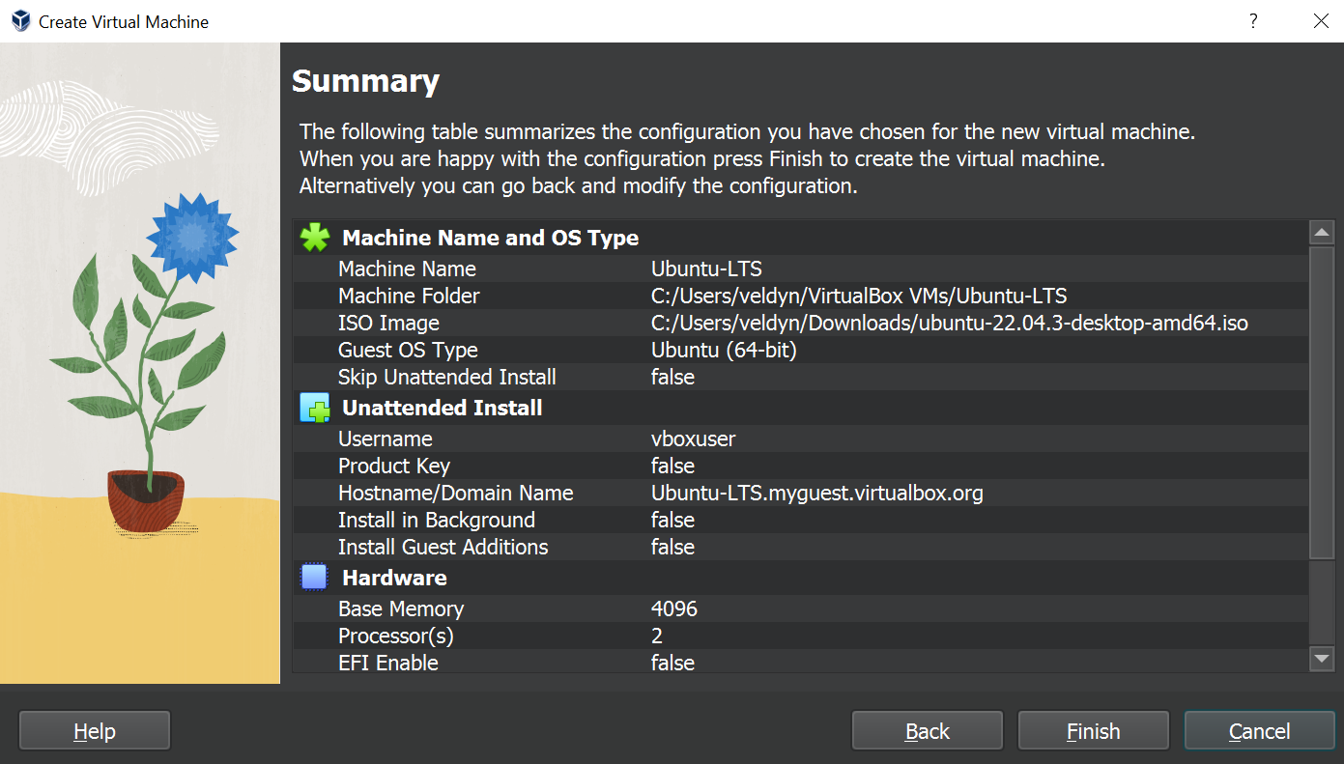

You should allocate a storage space of about 5GB to account for the operating system and still give you a bit of extra room to store files and perform basic tasks. Keep in mind that different operating systems take up different amounts of space, with some being more lightweight than others.

After clicking ‘**Next**’, you will be provided with a summary screen to verify your settings. Ensure everything is correct, and click ‘**Finish**’.

Congratulations! You have successfully created your first virtual machine. It should automatically open and complete the installation on its own. Once this is finished, feel free to tinker with the machine and experiment with the operating system. If you want to try some Linux commands, feel free to open **Terminal** and reference the commands in **Lab 1.0** if you need.

**In order to receive credit for this lab, please take the time to record your screen for a short 1 to 3 minute video showing the working virtual machine you just created so you can show your **lecturer**.**

### Resources

1. <https://www.vmware.com/content/vmware/vmware-published-sites/us/topics/glossary/content/virtual-machine.html.html>
2. Google Cloud VM Software - https://cloud.google.com/
3. VMWare Software - https://www.vmware.com/
4. Kernel Virtual Machine (KVM) Software - <https://www.linux-kvm.org/>

#### Getting Familiar with Virtualbox UI Reference

The ‘**Preferences**’ button will open an interface that allows you to change the display settings, input devices, and update the software among other features.

The ‘**Import**’ button will allow you to import virtual machines that others have created using Virtualbox that are stored in a .OVF format.

The ‘**Export**’ button will allow you to export your virtual machines to a file format that others can use to Import it to their Virtualbox installation using the .OVF format.

The ‘**New**’ button will allow you to create a new virtual machine. We’ll look at this further in just a moment.

The ‘**Add**’ Button is very similar to the ‘Import’ button, but will allow you to add virtual machines from a .vbox file.

#### Computer Hardware Refresher Reference

Before we start assigning hardware, it’s important to cover what the different components of a computer are, as well as their function. This will help develop a better understanding of the role of each component we will be assigning, and why they are important for our virtual machines to run smoothly.

Computer components can be compared to a well-coordinated orchestra. Just as how each instrument in an orchestra plays a unique role in creating beautiful music, each computer component plays a unique role in making your computer run smoothly.

The CPU (Central Processing Unit) or Processor is like the conductor of the orchestra, directing the other components to perform their tasks. The RAM (Random Access Memory) is like the sheet music, providing the necessary information for the CPU to execute instructions. The GPU (Graphics Processing Unit) is like the lead violinist, handling the most complex and visually demanding tasks. The hard drive is like the music library, storing all the data and programs that the computer needs to access. And the motherboard is like the stage, connecting all the components and providing a foundation for them to work together seamlessly.

Below is the provided answer key to the mini-quiz for your reference.

| CPU (Central Processing Unit) / Processor | Performs complex calculations and directs other components accordingly. The ‘brain’ of a computer. |
| --- | --- |
| Random Access Memory (RAM) | Memory in a computer that is dynamically reassigned to different tasks as needed. Also referred to as ‘Volatile memory’. |
| Graphics Processing Unit (GPU) | Performs complex tasks similarly to the CPU, but is less sophisticated. Like a worker on an assembly line, it does one job very well. |
| Hard Drive (HDD) / Solid State Drive (SSD) | Storage devices that store memory from the machine in a non-volatile space. Your personal files, preferences, and operating system are stored here. |
| Motherboard (MOBO) | A logic board that connects all the individual components to each other. |

#### 